# ANEXO UNIDAD 3 TERMO SIERRA

**Tabla 1. Parámetros del generador, transformador y la red eléctrica**

| **Parámetros del generador, transformador elevador y la red eléctrica** | | |
| --- | --- | --- |
| PARÁMETRO GENERADOR | UNIDAD | VALOR |
| Fabricante | General Electric | |
| Tipo | Round | |
| Potencia aparente Nominal | Sn [MVA] | 231 |
| Potencia activa nominal | Pn [MW] | 190.5 |
| Tensión de estator Nominal | Un [kV] | 18 |
| Corriente de estator nominal | In [A] | 6782 |
| Factor de potencia | Cos (phi) | 0.85 |
| Velocidad Nominal | fn [rpm] | 3600 |
| Resistencia de Armadura del Estator | ra [pu] | 0.003 |
| Reactancia de Fuga del Estator. | xl [pu] | 0.161 |
| Reactancia sincrónica eje D (no saturado) | xd [pu] | 1.967 |
| Reactancia sincrónica eje Q (no saturado) | xq [pu] | 1.889 |
| Reactancia transiente sincrónica eje D (no saturado) | xd' [pu] | 0.274 |
| Reactancia transiente sincrónica eje Q (no saturado) | xq' [pu] | 0.655 |
| Reactancia sub-transiente sincrónica eje D (no saturado) | xd'' [pu] | 0.2 |
| Reactancia sub-transiente sincrónica eje Q (no saturado) | xq'' [pu] | 0.2 |
| Constante de tiempo transiente (circuito abierto) sin carga eje D | Td'0 [s] | 5.297 |
| Constante de tiempo transiente (circuito abierto) sin carga eje Q | Tq''0 [s] | 0.655 |
| Constante de tiempo sub-transiente (circuito abierto) sin carga eje D | Td''0 [s] | 0.083 |
| Constante de tiempo sub-transiente (circuito abierto) sin carga eje Q | Tq''0 [s] | 0.032 |
| Constante de inercia ( todo el eje incluyendo la turbina) | H [MWs/MVA] | 5.43 |
| Impedancia de secuencia cero | X0[pu] | 0.1 |
| Resistenciade secuencia cero | r0[p.u.] | 0 |
| Impedancia de secuencia negativa | X-[pu] | 0.2 |
| Resistencia de secuencia negativa | r2 | 0 |
| TRANSFORMADOR | UNIDAD | VALOR |
| Potencia Nominal | Sn [MVA] | 242 |
| Tensión nominal del primario | U1n [kV] | 18 |
| Tensión nominal del secundario | U2n [kV] | 230 |
| Tensión de corto circuito en secuencia positiva | uk [%] | 15 |
| Tensión de corto circuito en secuencia negativa | uk0 [%] | 3 |
| TOPOLOGÍA DE RED | UNIDAD | VALOR |
| Potencia de corto-circuito del bus de Alta Tensión | [MVA] | 6000 |
| X/R | - | 10 |

# REGULADOR DE TENSIÓN (AVR)

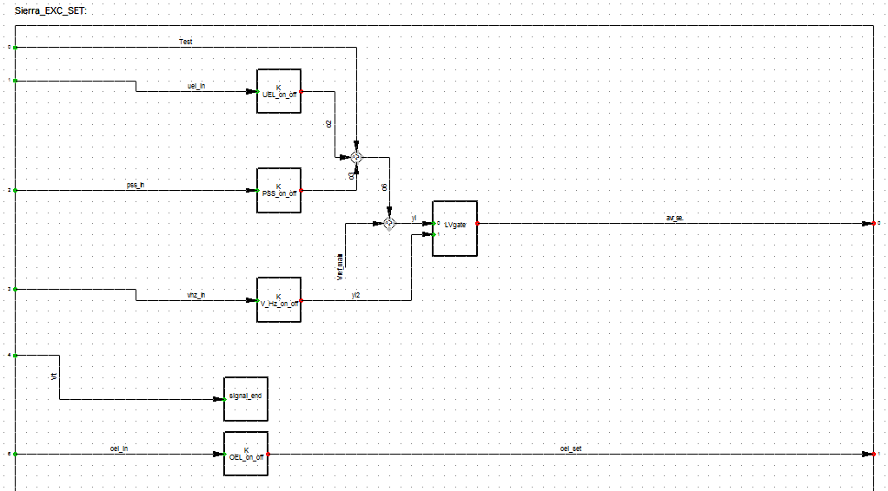

Figura 1. Modelo de referencia de AVR para las unidades a vapor

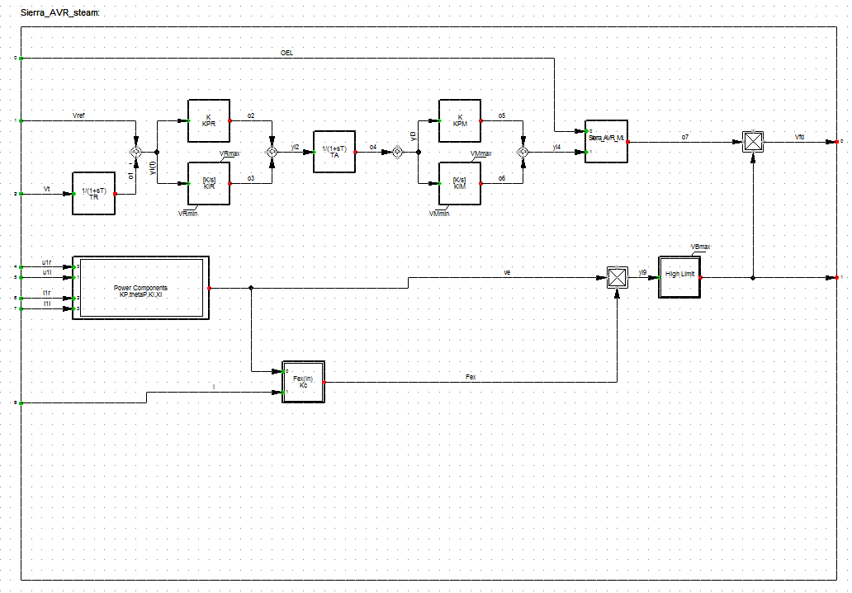

**Figura 2****.**  **Modelo del AVR para la unidad a Vapor**

**Tabla 2. Parámetros AVR**

| **Parámetros AVR** | | | |
| --- | --- | --- | --- |
| **Network Model >> Network Data >> Grid >> La_Sierra_Verification >> G3_AVR** | | | |
| Descripción | Parámetro | Unidad | Valor |
| Measurement Delay | TR | [s] | 0.01 |
| 1st Proportional Gain | KPR | [pu] | 4.25 |
| 2nd Proportional Gain | KPM | [pu] | 1. |
| 1st Integral Gain | KIR | [pu] | 4.25 |
| 2nd Integral Gain | KIM | [pu] | 0. |
| Measurement Delay | TA | [s] | 0.02 |
| Line Compensation Voltage Component (Magnitud) | KP | [pu] | 5.0592 |
| Voltage Component (angle) | thetaP | [deg.] | 0. |
| Line Compensation Current Component | KI | [pu] | 0. |
| Reactance of voltage component | Xl | [pu] | 0. |
| Field Current Input Gain | Kc | [pu] | 0.09 |
| Voltage Regulator Minimum Output | VRmin | [pu] | -0.87 |
| Fordward Minimum Output | VMmin | [pu] | -0.87 |
| Voltage Regulator Maximum Output | VRmax | [pu] | 0.6 |
| Fordward Maximum Output | VMmax | [pu] | 1. |
| Exciter voltage limit | VBmax | [pu] | 7.01 |

# SISTEMA ESTABILIZADOR DE POTENCIA (PSS)

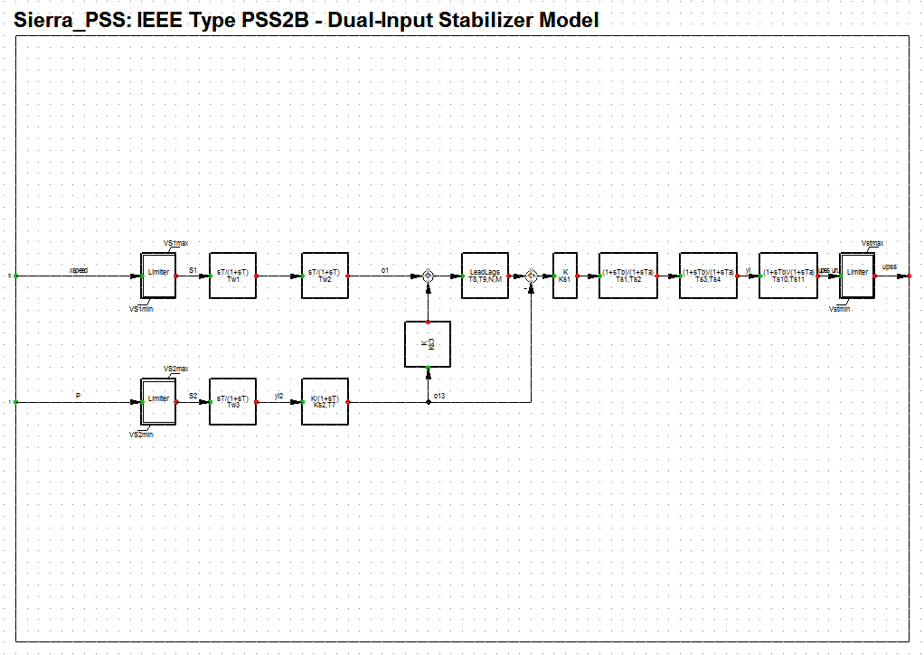

**Figura 3. Modelo PSS implementado Unidad a Vapor.**

**Tabla 3. Parámetros PSS**

|  |  |  |  |
| --- | --- | --- | --- |
| **Parámetros PSS** | | | |
| **Network Model >> Network Data >> Grid >> La_Sierra_Verification >> G3_PSS** | | | |
| **Descripción** | **Parámetro** | **Unidad** | **Valor** |
| **1st Washout 1th Time Constant** | **Tw1** | **[s]** | **2** |
| **1st Washout 2th Time Constant** | **Tw2** | **[s]** | **2** |
| **2nd Washout 1th Time Constant** | **Tw3** | **[s]** | **2** |
| **2nd Signal Transducer Factor** | **Ks2** | **[pu]** | **0.184** |
| **2nd Signal Transducer Time Constant** | **T7** | **[s]** | **2** |
| **Washouts Coupling Factor** | **Ks3** | **[pu]** | **1** |
| **PSS Gain** | **Ks1** | **[pu]** | **7** |
| **1st Lead-Lag Derivative Time Constant** | **Ts1** | **[s]** | **0.2** |
| **1st Lead-Lag Delay Time Constant** | **Ts2** | **[s]** | **0.04** |
| **2nd Lead-Lag Derivative Time Constant** | **Ts3** | **[s]** | **0.15** |
| **2nd Lead-Lag Delay Time Constant** | **Ts4** | **[s]** | **0.03** |
| **Ramp Tracking Filter Deriv. Time Constant** | **T8** | **[s]** | **0.5** |
| **Ramp Tracking Filter Delay Time Constant** | **T9** | **[s]** | **0.1** |
| **Ramp Tracking Filter** | **N** | **[-]** | **1** |
| **Ramp Tracking Filter** | **M** | **[-]** | **5** |
| **3rd Lead-Lag Derivative Time Constant** | **Ts10** | **[s]** | **0** |
| **3rd Lead-Lag Delay Time Constant** | **Ts11** | **[s]** | **0** |
| **Controller Minimum Output** | **Vstmin** | **[pu]** | **-0.1** |
| **Input Signal 1 Minimum Limit** | **VS1min** | **[pu]** | **-1** |
| **Input Signal 2 Minimum Limit** | **VS2min** | **[pu]** | **-1** |
| **Controller Maximum Output** | **Vstmax** | **[pu]** | **0.15** |
| **Input Signal 1 Maximum Limit** | **VS1max** | **[pu]** | **1** |
| **Input Signal 2 Maximum Limit** | **VS2max** | **[pu]** | **1** |

# LIMITADOR DE SUBEXCITACIÓN (UEL)

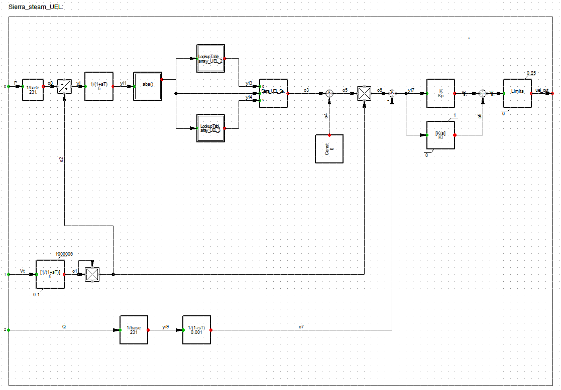

Figura 4. Modelo del limitador UEL.

**Tabla 4. Parámetros UEL**

| **Parámetros del limitador UEL** | | | |
| --- | --- | --- | --- |
| **Network Model >> Network Data >> Grid >> La_Sierra_Verification >> G3_UEL** | | | |
| Parámetro | | Unidad | Valor |
| Kp | | pu | 4 |
| KI | | pu | 3 |
| UEL_2 | x0 | pu | 0.3 |
| x1 | pu | 0.6 |
| x2 | pu | 0.9 |
| x3 | pu | 1.2 |
| x4 | pu | -0.3112 |
| x5 | pu | -0.281 |
| x6 | pu | -0.2334 |
| x7 | pu | 0.46 |
| UEL_3 | x0 | pu | 0 |
| x1 | pu | 0.3 |
| y0 | pu | -0.2636 |
| y1 | pu | -0.3112 |

# LIMITADOR DE SOBRE EXCITACIÓN (OEL)

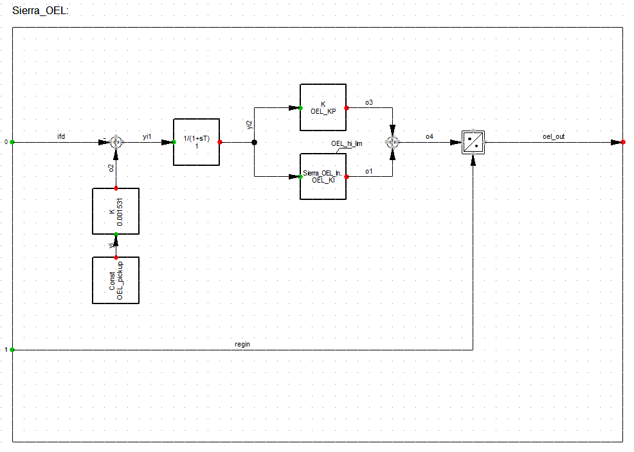

**Figura 5. Modelo del OEL.**

**Tabla 5. Parámetros OEL**

|  |  |  |  |
| --- | --- | --- | --- |
| **Parámetros limitador OEL unidad a Vapor** | | | |
| **Network Model >> Network Data >> Grid >> La_Sierra_Verification >> G3_OEL** | | | |
| Parámetro | Unidad | Valor | Descripcion |
| OEL_pickup | A | 1600 | OEL Pickup Current |
| OEL_KP | pu | 30 | Constante Proporcional |
| OEL_KI | pu | 2 | Constante Integral |
| OEL_hi_lim | A | 1800 | OEL Hi-Limit Current |

# LIMITADOR RELACIÓN VOLTIOS – HERTZ (V/Hz)

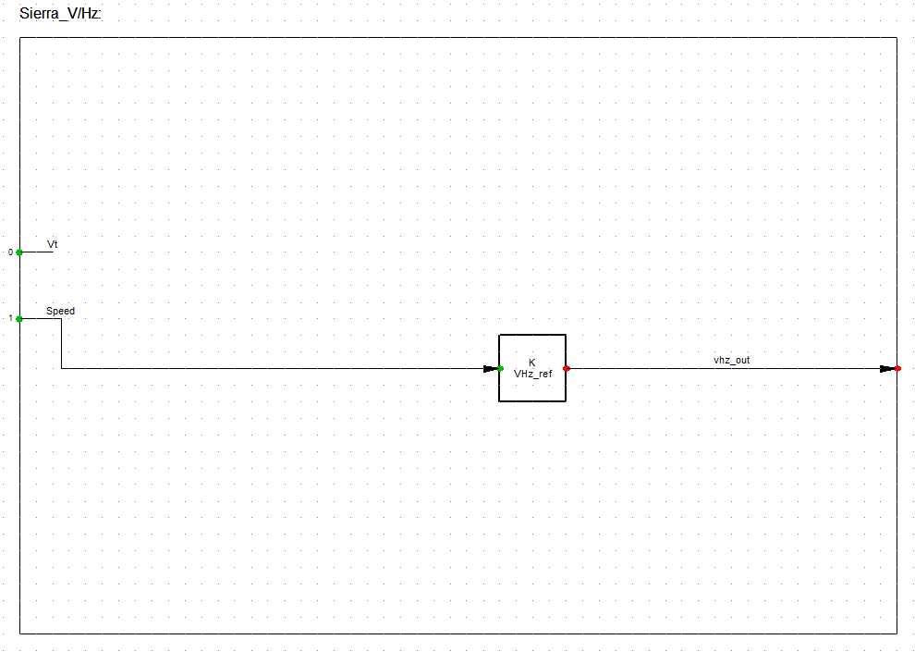

**Figura 6.** Modelo del limitador V/Hz.

**Tabla 6. Parámetros V/Hz**

|  |  |  |  |
| --- | --- | --- | --- |
| **Parámetros V/Hz** | | | |
| **Network Model >> Network Data >> Grid >> La_Sierra_Verification >> G3_V/Hz** | | | |
| Descripción | Parámetro | Unidad | Valor |
| VHz Ratio Limit | VHz_ref | [p.u.] | 1.09 |