Anexos

Prado Unidad 1

Informe:

EE-EN-2019-0134_RH_Informe_Homologación_CH_HidroPrado_U1

|  |  |  |
| --- | --- | --- |
| *Generador Sincrónico* | | |
| Parámetro | Valor | Unidad |
| Inertia Constant H | 4.090 | [s] |
| rstr | 0.000 | [pu] |
| xl | 0.150 | [pu] |
| xd | 1.404 | [pu] |
| xq | 0.847 | [pu] |
| Rotor Type | Salient Pole | - |
| xrld | 0.000 | [pu] |
| xrlq | 0.000 | [pu] |
| x'd | 0.250 | [pu] |
| x''d | 0.200 | [pu] |
| x''q | 0.210 | [pu] |
| T'd0 | 4.700 | [s] |
| T''d0 | 0.018 | [s] |
| T''q0 | 0.032 | [s] |
| SG10 | 0.055 | [pu] |
| SG12 | 0.230 | [pu] |

|  |  |  |  |  |
| --- | --- | --- | --- | --- |
| *Dsl: vco_THYNE5_U1* | | | | |
| Nombre | Valor | Unidad | Tipo | Descripción |
| Tf | 0.009 | [s] | d | Cte. de tiempo medición V |
| TiVHz | 3.1872 | [seg] | d | Constante de tiempo I VHz |
| Tfi | 0.005 | [s] | d | Cte. de tiempo medición I |
| Kp | 11.22 | [pu] | d | Ganancia proporcional PID tensión |
| Kb | 7.5 | [pu] | d | Ganancia puente |
| Kpi | 69.19 | [pu] | d | Ganancia proporcional P corriente |
| Ti | 0.35 | [pu] | d | Cte. de tiempo integral PID tensión |
| Kd | 0 | [pu] | d | Ganancia derivativa PID tensión |
| Td | 0.0059 | [pu] | d | Cte. de tiempo derivativa PID tensión |
| KpI | 4 | [pu] | d | Ganancia proporcional PI Imax |
| TiI | 0.06 | [seg] | d | Constante de tiempo PI Imax |
| IFDMax | 2.46 | [pu] | d | Limite instantáneo de corriente de campo |
| alfa | 0 | [pu] | d | Droop P |
| Tfd | 0 | [seg] | d | Constante de tiempo Droop |
| beta | 0 | [pu] | d | Droop Q |
| VHz_min | -0.5 | [pu] | d | Límite inferior VHz |
| D_min | 0 | [pu] | d | Lim. inf. derivativo |
| PID_min | -50 | [pu] | d | Lim. inf. PID |
| P_min | 5.11 | [°] | d | Angulo mínimo de disparo |
| I_min | -12 | [pu] | d | Lim. inf. integral |
| PI_min | -1000 | [pu] | d | Limite PI Imax |
| D_max | 0 | [pu] | d | Lim. sup. derivativo |
| PID_max | 50 | [pu] | d | Lim. sup. PID |
| P_max | 153.6 | [°] | d | Angulo máximo de disparo |
| I_max | 3 | [pu] | d | Lim. sup. integral |

|  |  |  |
| --- | --- | --- |
| Frec: |  |  |
| Size | 3 |  |
| Index | X | Y |
| 1 | 0 | 0 |
| 2 | 1 | 1.045 |
| 3 | 2 | 1.045 |

|  |  |  |  |  |
| --- | --- | --- | --- | --- |
| *Dsl: oel_THYNE5_U1* | | | | |
| Nombre | Valor | Unidad | Tipo | Descripción |
| T | 21 | [s] | d | Cte. de temporización |
| IPMAXV | 2.139 | [pu] | d | Umbral de corriente OEL temporizado |
| Ti | 100 | [pu] | d | Ganancia OEL temporizado |
| IPZONE | 0.98 | [pu] | d | Histéresis OEL temporizado |
| y_min | -10 | [pu] | d | Límite inferior OEL temporizado |

|  |  |  |  |  |
| --- | --- | --- | --- | --- |
| *Dsl: uel_THYNE5_U1* | | | | |
| Nombre | Valor | Unidad | Tipo | Descripción |
| Pbase | 18 | [MW] | d | Potencia Activa base |
| Qbase | 18 | [MVAr] | d | Potencia Reactiva base |
| Xq | 2.31 | [pu] | d | Reactancia en cuadratura |
| Xn | 0 | [pu] | d | Reactancia de vinculación |
| Kd | 1.5 | [pu] | d | Ganancia derivativa UEL |
| Td | 0.25 | [pu] | d | Cte. de tiempo derivativa UEL |
| Ti | 400 | [pu] | d | Cte. de tiempo integral UEL |
| Kp | 0.0005 | [pu] | d | Ganancia proporcional UEL |
| DeltaP | 87 | [°] | d | Angulo estacionario limite |
| DeltaT | 97 | [°] | d | Angulo temporal limite |
| D_min | 0 | [pu] | d | Lim. inf. derivativo |
| PI_min | 0 | [pu] | d | Lim. inf. PI |
| D_max | 14 | [pu] | d | Lim. sup. derivativo |
| PI_max | 14 | [pu] | d | Lim. sup. PI |

|  |  |  |  |  |
| --- | --- | --- | --- | --- |
| *Dsl: scl_THYNE5_U1* | | | | |
| Nombre | Valor | Unidad | Tipo | Descripción |
| T | 165 | [s] | d | Cte. de temporización |
| IPMAXV | 1.091 | [pu] | d | Umbral de corriente SCL |
| Ti | 100 | [pu] | d | Ganancia SCL |
| IPZONE | 0.98 | [pu] | d | Histéresis SCL |
| IBWG | 0.5 | [MVAr] | d | Banda muerta de actuación |
| y_min | -10 | [pu] | d | Límite inferior SCL |

|  |  |  |  |  |
| --- | --- | --- | --- | --- |
| *Dsl: pss_THYNE5_U1* | | | | |
| Nombre | Valor | Unidad | Tipo | Descripción |
| T1 | 0.02 | [s] | d | Cte. de tiempo PT1 |
| T2 | 0.02 | [s] | d | Cte. de tiempo PT1 |
| Pbase | 18 | [MW] | d | Potencia base |
| Tf | 5 | [s] | d | Cte. de tiempo del filtro |
| T3 | 4.22 | [s] | d | Cte. de tiempo DT1 |
| T4 | 4.22 | [s] | d | Cte. de tiempo DT1 |
| T5 | 4.22 | [s] | d | Cte. de tiempo DT1 |
| K1 | 6.77 | [pu] | d | Ganancia velocidad |
| T6 | 2.15 | [s] | d | Cte. de tiempo velocidad |
| K2 | 0.5 | [pu] | d | Ganancia aceleración |
| a | -0.5 | [pu] | d | Ganancia PSS |
| p | 0 | [-] | d | Ajuste de fase |
| PHigh | 0.1 | [pu] | d | Umbral de activación del PSS |
| PLow | 0 | [pu] | d | Umbral de desactivación del PSS |
| pss_min | -0.098 | [pu] | d | Límite inferior PSS |
| pss_max | 0.098 | [pu] | d | Límite superior PSS |

|  |  |  |  |  |
| --- | --- | --- | --- | --- |
| *Dsl: ConHidr_Data* | | | | |
| Nombre | Valor | Unidad | Tipo | Descripción |
| pNL1 | 0.101 | [pu] | d | Caudal de vacío Unidad 1 |
| Trate1 | 18 |  | d |  |
| pNL2 | 0.101 | [pu] | d | Caudal de vacío Unidad 2 |
| Trate2 | 18 |  | d |  |
| pNL3 | 0.101 | [pu] | d | Caudal de vacío Unidad 3 |
| Trate3 | 18 |  | d |  |
| Twr1 | 2.6592 | [seg] | d | Tw ramal 1 |
| Ter1 | 0.2221 | [seg] | d | Te ramal 1 |
| f2r1 | 0.2 | [pu] | d | Coeficiente de rozamiento ramal 1 |

|  |  |  |  |  |
| --- | --- | --- | --- | --- |
| *Dsl: GOV_U1* | | | | |
| Nombre | Valor | Unidad | Tipo | Descripción |
| Tpos | 0 | [pu] | d | Cte. derivativa ctrl. posición |
| Kpos | 4.6 | [pu] | d | Ganancia control de posición |
| Kpint | 2 | [pu] | d | Ganancia ctrl. posición valv. intermedia |
| Tint | 0.003 | [pu] | d | Cte. derivativa ctrl. posición valv. intermedia |
| Kpist | 0.2 | [pu] | d | Ganancia posicionador |
| Ksv | 1 | [pu] | d | Cte. servovalvula |
| Kvi | 4.8 | [pu] | d | Cte. válvula intermedia |
| Tt | 0.05 | [s] | d | Cte tiempo transductor de posición |
| Tvi | 0.8 | [pu] | d | Cte. tiempo válvula intermedia |
| Tsv | 0.05 | [pu] | d | Cte. tiempo servovalvula |
| DBP | 0 | [pu] | d | Banda muerta posición |
| Droop | 0.04 | [pu/pu] | d | Estatismo |
| Db | 0.0005 | [pu] | d | Banda muerta frecuencia |
| pNL | 0.101 | [pu] | d | Potencia de vacío |
| Tw | 0.1738 | [seg] | d | Constante de tiempo del agua |
| D | 0 | [pu] | d | Constante de turbina |
| Trate | 18 | [MW] | d | Potencia nominal de turbina |
| MinOpen | -0.06 | [pu] | d | Lim Inf |
| MaxOpen | 0.06 | [pu] | d | Lim Sup |
|  |  |  |  |  |
|  |  |  |  |  |
| PosPmech: |  |  |  |  |
| Size | 13 |  |  |  |
| Index | X | Y |  |  |
| 1 | 0 | 0 |  |  |
| 2 | 0.1 | 0.058 |  |  |
| 3 | 0.2 | 0.127 |  |  |
| 4 | 0.3 | 0.235 |  |  |
| 5 | 0.4 | 0.369 |  |  |
| 6 | 0.44 | 0.402 |  |  |
| 7 | 0.5 | 0.461 |  |  |
| 8 | 0.617 | 0.581 |  |  |
| 9 | 0.66 | 0.632 |  |  |
| 10 | 0.76 | 0.699 |  |  |
| 11 | 0.815 | 0.73 |  |  |
| 12 | 0.87 | 0.762 |  |  |
| 13 | 1.1 | 0.924 |  |  |

Prado Unidad 2

Informe:

EE-EN-2019-0150_RI_Informe_Homologación_CH_HidroPrado_U2

|  |  |  |
| --- | --- | --- |
| *Generador Sincrónico* | | |
| Parámetro | Valor | Unidad |
| Inertia Constant H | 4.090 | [s] |
| rstr | 0.000 | [pu] |
| xl | 0.150 | [pu] |
| xd | 1.404 | [pu] |
| xq | 0.847 | [pu] |
| Rotor Type | Salient Pole | - |
| xrld | 0.000 | [pu] |
| xrlq | 0.000 | [pu] |
| x'd | 0.250 | [pu] |
| x''d | 0.200 | [pu] |
| x''q | 0.210 | [pu] |
| T'd0 | 4.610 | [s] |
| T''d0 | 0.018 | [s] |
| T''q0 | 0.032 | [s] |
| SG10 | 0.055 | [pu] |
| SG12 | 0.240 | [pu] |

|  |  |  |  |  |
| --- | --- | --- | --- | --- |
| *Dsl: vco_THYNE5_U2* | | | | |
| Nombre | Valor | Unidad | Tipo | Descripción |
| Tf | 0.009 | [s] | d | Cte. de tiempo medición V |
| TiVHz | 3.984 | [seg] | d | Constante de tiempo I VHz |
| Tfi | 0.005 | [s] | d | Cte. de tiempo medición I |
| Kp | 6.6 | [pu] | d | Ganancia proporcional PID tensión |
| Kb | 7.5 | [pu] | d | Ganancia puente |
| Kpi | 69.19 | [pu] | d | Ganancia proporcional P corriente |
| Ti | 0.35 | [pu] | d | Cte. de tiempo integral PID tensión |
| Kd | 0 | [pu] | d | Ganancia derivativa PID tensión |
| Td | 0.0059 | [pu] | d | Cte. de tiempo derivativa PID tensión |
| KpI | 4 | [pu] | d | Ganancia proporcional PI Imax |
| TiI | 0.06 | [seg] | d | Constante de tiempo PI Imax |
| IFDMax | 2.37 | [pu] | d | Limite instantáneo de corriente de campo |
| alfa | 0 | [pu] | d | Droop P |
| Tfd | 0 | [seg] | d | Constante de tiempo Droop |
| beta | 0 | [pu] | d | Droop Q |
| VHz_min | -0.5 | [pu] | d | Límite inferior VHz |
| D_min | 0 | [pu] | d | Lim. inf. derivativo |
| PID_min | -50 | [pu] | d | Lim. inf. PID |
| P_min | 8.2 | [°] | d | Angulo mínimo de disparo |
| I_min | -12 | [pu] | d | Lim. inf. integral |
| PI_min | -1000 | [pu] | d | Limite PI Imax |
| D_max | 0 | [pu] | d | Lim. sup. derivativo |
| PID_max | 50 | [pu] | d | Lim. sup. PID |
| P_max | 151.6 | [°] | d | Angulo máximo de disparo |
| I_max | 3 | [pu] | d | Lim. sup. integral |
| Frec |  |  | [d,d] |  |
|  |  |  |  |  |
| Frec: |  |  |  |  |
| Size | 3 |  |  |  |
| Index | X | Y |  |  |
| 1 | 0 | 0 |  |  |
| 2 | 1 | 1.045 |  |  |
| 3 | 2 | 1.045 |  |  |

|  |  |  |  |  |
| --- | --- | --- | --- | --- |
| *Dsl: oel_THYNE5_U2* | | | | |
| Nombre | Valor | Unidad | Tipo | Descripción |
| T | 14.7 | [s] | d | Cte. de temporización |
| IPMAXV | 2.139 | [pu] | d | Umbral de corriente OEL temporizado |
| Ti | 100 | [pu] | d | Ganancia OEL temporizado |
| IPZONE | 0.98 | [pu] | d | Histéresis OEL temporizado |
| y_min | -10 | [pu] | d | Límite inferior OEL temporizado |

|  |  |  |  |  |
| --- | --- | --- | --- | --- |
| *Dsl: uel_THYNE5_U2* | | | | |
| Nombre | Valor | Unidad | Tipo | Descripción |
| Pbase | 18 | [MW] | d | Potencia Activa base |
| Qbase | 18 | [MVAr] | d | Potencia Reactiva base |
| Xq | 2.31 | [pu] | d | Reactancia en cuadratura |
| Xn | 0 | [pu] | d | Reactancia de vinculación |
| Kd | 1.5 | [pu] | d | Ganancia derivativa UEL |
| Td | 0.25 | [pu] | d | Cte. de tiempo derivativa UEL |
| Ti | 400 | [pu] | d | Cte. de tiempo integral UEL |
| Kp | 0.0005 | [pu] | d | Ganancia proporcional UEL |
| DeltaP | 87 | [°] | d | Angulo estacionario limite |
| DeltaT | 97 | [°] | d | Angulo temporal limite |
| D_min | 0 | [pu] | d | Lim. inf. derivativo |
| PI_min | 0 | [pu] | d | Lim. inf. PI |
| D_max | 14 | [pu] | d | Lim. sup. derivativo |
| PI_max | 14 | [pu] | d | Lim. sup. PI |

|  |  |  |  |  |
| --- | --- | --- | --- | --- |
| *Dsl: scl_THYNE5_U2* | | | | |
| Nombre | Valor | Unidad | Tipo | Descripción |
| T | 47.5 | [s] | d | Cte. de temporización |
| IPMAXV | 1.121 | [pu] | d | Umbral de corriente SCL |
| Ti | 100 | [pu] | d | Ganancia SCL |
| IPZONE | 0.98 | [pu] | d | Histéresis SCL |
| IBWG | 0.5 | [MVAr] | d | Banda muerta de actuación |
| y_min | -10 | [pu] | d | Límite inferior SCL |

|  |  |  |  |  |
| --- | --- | --- | --- | --- |
| *Dsl: pss_THYNE5_U2* | | | | |
| Nombre | Valor | Unidad | Tipo | Descripción |
| T1 | 0.02 | [s] | d | Cte. de tiempo PT1 |
| T2 | 0.02 | [s] | d | Cte. de tiempo PT1 |
| Pbase | 18 | [MW] | d | Potencia base |
| Tf | 5 | [s] | d | Cte. de tiempo del filtro |
| T3 | 4.22 | [s] | d | Cte. de tiempo DT1 |
| T4 | 4.22 | [s] | d | Cte. de tiempo DT1 |
| T5 | 4.22 | [s] | d | Cte. de tiempo DT1 |
| K1 | 6.77 | [pu] | d | Ganancia velocidad |
| T6 | 2.15 | [s] | d | Cte. de tiempo velocidad |
| K2 | 0.5 | [pu] | d | Ganancia aceleración |
| a | -0.5 | [pu] | d | Ganancia PSS |
| p | 0 | [-] | d | Ajuste de fase |
| PHigh | 0.1 | [pu] | d | Umbral de activación del PSS |
| PLow | 0 | [pu] | d | Umbral de desactivación del PSS |
| pss_min | -0.098 | [pu] | d | Límite inferior PSS |
| pss_max | 0.098 | [pu] | d | Límite superior PSS |

|  |  |  |  |  |
| --- | --- | --- | --- | --- |
| *Dsl: ConHidr_Data* | | | | |
| Nombre | Valor | Unidad | Tipo | Descripción |
| pNL1 | 0.101 | [pu] | d | Caudal de vacío Unidad 1 |
| Trate1 | 18 |  | d |  |
| pNL2 | 0.101 | [pu] | d | Caudal de vacío Unidad 2 |
| Trate2 | 18 |  | d |  |
| pNL3 | 0.101 | [pu] | d | Caudal de vacío Unidad 3 |
| Trate3 | 18 |  | d |  |
| Twr1 | 2.6592 | [seg] | d | Tw ramal 1 |
| Ter1 | 0.2221 | [seg] | d | Te ramal 1 |
| f2r1 | 0.2 | [pu] | d | Coeficiente de rozamiento ramal 1 |

|  |  |  |  |  |
| --- | --- | --- | --- | --- |
| *Dsl: GOV_U2* | | | | |
| Nombre | Valor | Unidad | Tipo | Descripción |
| Tpos | 0 | [pu] | d | Cte. derivativa ctrl. posición |
| Kpos | 9 | [pu] | d | Ganancia control de posición |
| Kpint | 2 | [pu] | d | Ganancia ctrl. posición valv. intermedia |
| Tint | 0.003 | [pu] | d | Cte. derivativa ctrl. posición valv. intermedia |
| Kpist | 0.1 | [pu] | d | Ganancia posicionador |
| Ksv | 1 | [pu] | d | Cte. servovalvula |
| Kvi | 4.8 | [pu] | d | Cte. válvula intermedia |
| Tt | 0.05 | [s] | d | Cte tiempo transductor de posición |
| Tvi | 0.8 | [pu] | d | Cte. tiempo válvula intermedia |
| Tsv | 0.05 | [pu] | d | Cte. tiempo servovalvula |
| DBP | 0 | [pu] | d | Banda muerta posición |
| Droop | 0.05 | [pu/pu] | d | Estatismo |
| Db | 0.0005 | [pu] | d | Banda muerta frecuencia |
| pNL | 0.101 | [pu] | d | Potencia de vacío |
| Tw | 0.065 | [seg] | d | Constante de tiempo del agua |
| D | 0 | [pu] | d | Constante de turbina |
| Trate | 18 | [MW] | d | Potencia nominal de turbina |
| MinOpen | -0.06 | [pu] | d | Lim Inf |
| MaxOpen | 0.06 | [pu] | d | Lim Sup |
|  |  |  |  |  |
|  |  |  |  |  |
| PosPmech: |  |  |  |  |
| Size | 14 |  |  |  |
| Index | X | Y |  |  |
| 1 | 0 | 0 |  |  |
| 2 | 0.1 | 0.028 |  |  |
| 3 | 0.2 | 0.124 |  |  |
| 4 | 0.3 | 0.228 |  |  |
| 5 | 0.4 | 0.353 |  |  |
| 6 | 0.44 | 0.403 |  |  |
| 7 | 0.5 | 0.445 |  |  |
| 8 | 0.53 | 0.482 |  |  |
| 9 | 0.665 | 0.621 |  |  |
| 10 | 0.71 | 0.667 |  |  |
| 11 | 0.76 | 0.703 |  |  |
| 12 | 0.815 | 0.727 |  |  |
| 13 | 0.87 | 0.763 |  |  |
| 14 | 1.1 | 0.914 |  |  |

Prado Unidad 3

Informe:

EE-EN-2019-0168_RI_Informe_Homologación_CH_HidroPrado_U3

|  |  |  |
| --- | --- | --- |
| *Generador Sincrónico* | | |
| Parámetro | Valor | Unidad |
| Inertia Constant H | 4.090 | [s] |
| rstr | 0.000 | [pu] |
| xl | 0.150 | [pu] |
| xd | 1.404 | [pu] |
| xq | 0.847 | [pu] |
| Rotor Type | Salient Pole | - |
| xrld | 0.000 | [pu] |
| xrlq | 0.000 | [pu] |
| x'd | 0.250 | [pu] |
| x''d | 0.200 | [pu] |
| x''q | 0.210 | [pu] |
| T'd0 | 4.610 | [s] |
| T''d0 | 0.018 | [s] |
| T''q0 | 0.032 | [s] |
| SG10 | 0.055 | [pu] |
| SG12 | 0.240 | [pu] |

|  |  |  |  |  |
| --- | --- | --- | --- | --- |
| *Dsl: vco_THYNE5_U3* | | | | |
| Nombre | Valor | Unidad | Tipo | Descripción |
| Tf | 0.009 | [s] | d | Cte. de tiempo medición V |
| TiVHz | 3.1872 | [seg] | d | Constante de tiempo I VHz |
| Tfi | 0.005 | [s] | d | Cte. de tiempo medición I |
| Kp | 11.22 | [pu] | d | Ganancia proporcional PID tensión |
| Kb | 7.5 | [pu] | d | Ganancia puente |
| Kpi | 69.19 | [pu] | d | Ganancia proporcional P corriente |
| Ti | 0.35 | [pu] | d | Cte. de tiempo integral PID tensión |
| Kd | 0 | [pu] | d | Ganancia derivativa PID tensión |
| Td | 0.0059 | [pu] | d | Cte. de tiempo derivativa PID tensión |
| KpI | 4 | [pu] | d | Ganancia proporcional PI Imax |
| TiI | 0.06 | [seg] | d | Constante de tiempo PI Imax |
| IFDMax | 2.47 | [pu] | d | Limite instantáneo de corriente de campo |
| alfa | 0 | [pu] | d | Droop P |
| Tfd | 0 | [seg] | d | Constante de tiempo Droop |
| beta | 0 | [pu] | d | Droop Q |
| VHz_min | -0.5 | [pu] | d | Límite inferior VHz |
| D_min | 0 | [pu] | d | Lim. inf. derivativo |
| PID_min | -50 | [pu] | d | Lim. inf. PID |
| P_min | 5.11 | [°] | d | Angulo mínimo de disparo |
| I_min | -12 | [pu] | d | Lim. inf. integral |
| PI_min | -1000 | [pu] | d | Limite PI Imax |
| D_max | 0 | [pu] | d | Lim. sup. derivativo |
| PID_max | 50 | [pu] | d | Lim. sup. PID |
| P_max | 153.6 | [°] | d | Angulo máximo de disparo |
| I_max | 3 | [pu] | d | Lim. sup. integral |
| Frec |  |  | [d,d] |  |
|  |  |  |  |  |
| Frec: |  |  |  |  |
| Size | 3 |  |  |  |
| Index | X | Y |  |  |
| 1 | 0 | 0 |  |  |
| 2 | 1 | 1.045 |  |  |
| 3 | 2 | 1.045 |  |  |

|  |  |  |  |  |
| --- | --- | --- | --- | --- |
| *Dsl: oel_THYNE5_U3* | | | | |
| Nombre | Valor | Unidad | Tipo | Descripción |
| T | 22 | [s] | d | Cte. de temporización |
| IPMAXV | 2.139 | [pu] | d | Umbral de corriente OEL temporizado |
| Ti | 100 | [pu] | d | Ganancia OEL temporizado |
| IPZONE | 0.98 | [pu] | d | Histéresis OEL temporizado |
| y_min | -10 | [pu] | d | Límite inferior OEL temporizado |

|  |  |  |  |  |
| --- | --- | --- | --- | --- |
| *Dsl: uel_THYNE5_U3* | | | | |
| Nombre | Valor | Unidad | Tipo | Descripción |
| Pbase | 18 | [MW] | d | Potencia Activa base |
| Qbase | 18 | [MVAr] | d | Potencia Reactiva base |
| Xq | 2.3 | [pu] | d | Reactancia en cuadratura |
| Xn | 0 | [pu] | d | Reactancia de vinculación |
| Kd | 1.5 | [pu] | d | Ganancia derivativa UEL |
| Td | 0.25 | [pu] | d | Cte. de tiempo derivativa UEL |
| Ti | 400 | [pu] | d | Cte. de tiempo integral UEL |
| Kp | 0.0005 | [pu] | d | Ganancia proporcional UEL |
| DeltaP | 87 | [°] | d | Angulo estacionario limite |
| DeltaT | 97 | [°] | d | Angulo temporal limite |
| D_min | 0 | [pu] | d | Lim. inf. derivativo |
| PI_min | 0 | [pu] | d | Lim. inf. PI |
| D_max | 14 | [pu] | d | Lim. sup. derivativo |
| PI_max | 14 | [pu] | d | Lim. sup. PI |

|  |  |  |  |  |
| --- | --- | --- | --- | --- |
| *Dsl: scl_THYNE5_U3* | | | | |
| Nombre | Valor | Unidad | Tipo | Descripción |
| T | 81 | [s] | d | Cte. de temporización |
| IPMAXV | 1.095 | [pu] | d | Umbral de corriente SCL |
| Ti | 100 | [pu] | d | Ganancia SCL |
| IPZONE | 0.98 | [pu] | d | Histéresis SCL |
| IBWG | 0.5 | [MVAr] | d | Banda muerta de actuación |
| y_min | -10 | [pu] | d | Límite inferior SCL |

|  |  |  |  |  |
| --- | --- | --- | --- | --- |
| *Dsl: pss_THYNE5_U3* | | | | |
| Nombre | Valor | Unidad | Tipo | Descripción |
| T1 | 0.02 | [s] | d | Cte. de tiempo PT1 |
| T2 | 0.02 | [s] | d | Cte. de tiempo PT1 |
| Pbase | 18 | [MW] | d | Potencia base |
| Tf | 5 | [s] | d | Cte. de tiempo del filtro |
| T3 | 4.22 | [s] | d | Cte. de tiempo DT1 |
| T4 | 4.22 | [s] | d | Cte. de tiempo DT1 |
| T5 | 4.22 | [s] | d | Cte. de tiempo DT1 |
| K1 | 6.77 | [pu] | d | Ganancia velocidad |
| T6 | 2.15 | [s] | d | Cte. de tiempo velocidad |
| K2 | 0.5 | [pu] | d | Ganancia aceleración |
| a | -0.5 | [pu] | d | Ganancia PSS |
| p | 0 | [-] | d | Ajuste de fase |
| PHigh | 0.1 | [pu] | d | Umbral de activación del PSS |
| PLow | 0 | [pu] | d | Umbral de desactivación del PSS |
| pss_min | -0.098 | [pu] | d | Límite inferior PSS |
| pss_max | 0.098 | [pu] | d | Límite superior PSS |

|  |  |  |  |  |  |  |  |  |
| --- | --- | --- | --- | --- | --- | --- | --- | --- |
| *Dsl: ConHidr_Data* | | | | | | | | |
| Nombre | Valor | | Unidad | | Tipo | Descripción | | |
| pNL1 | 0.101 | | [pu] | | d | Caudal de vacío Unidad 1 | | |
| Trate1 | 18 | |  | | d |  | | |
| pNL2 | 0.101 | | [pu] | | d | Caudal de vacío Unidad 2 | | |
| Trate2 | 18 | |  | | d |  | | |
| pNL3 | 0.101 | | [pu] | | d | Caudal de vacío Unidad 3 | | |
| Trate3 | 18 | |  | | d |  | | |
| Twr1 | 2.6592 | | [seg] | | d | Tw ramal 1 | | |
| Ter1 | 0.2221 | | [seg] | | d | Te ramal 1 | | |
| f2r1 | 0.2 | | [pu] | | d | Coeficiente de rozamiento ramal 1 | | |
| *Dsl: GOV_U3* | | | | | | | | | |
| Nombre | | Valor | | Unidad | | | Tipo | Descripción | |
| Tpos | | 0 | | [pu] | | | d | Cte. derivativa ctrl. posición | |
| Kpos | | 4 | | [pu] | | | d | Ganancia control de posición | |
| Kpint | | 2 | | [pu] | | | d | Ganancia ctrl. posición valv. intermedia | |
| Tint | | 0.003 | | [pu] | | | d | Cte. derivativa ctrl. posición valv. intermedia | |
| Kpist | | 0.1 | | [pu] | | | d | Ganancia posicionador | |
| Ksv | | 1 | | [pu] | | | d | Cte. servovalvula | |
| Kvi | | 4.8 | | [pu] | | | d | Cte. válvula intermedia | |
| Tt | | 0.05 | | [s] | | | d | Cte tiempo transductor de posición | |
| Tvi | | 0.8 | | [pu] | | | d | Cte. tiempo válvula intermedia | |
| Tsv | | 0.05 | | [pu] | | | d | Cte. tiempo servovalvula | |
| DBP | | 0 | | [pu] | | | d | Banda muerta posición | |
| Droop | | 0.05 | | [pu/pu] | | | d | Estatismo | |
| Db | | 0.0005 | | [pu] | | | d | Banda muerta frecuencia | |
| pNL | | 0.101 | | [pu] | | | d | Potencia de vacío | |
| Tw | | 0.061 | | [seg] | | | d | Constante de tiempo del agua | |
| D | | 0 | | [pu] | | | d | Constante de turbina | |
| Trate | | 18 | | [MW] | | | d | Potencia nominal de turbina | |
| MinOpen | | -0.06 | | [pu] | | | d | Lim Inf | |
| MaxOpen | | 0.06 | | [pu] | | | d | Lim Sup | |
|  | |  | |  | | |  |  | |
|  | |  | |  | | |  |  | |
| PosPmech: | |  | |  | | |  |  | |
| Size | | 17 | |  | | |  |  | |
| Index | | X | | Y | | |  |  | |
| 1 | | 0 | | 0 | | |  |  | |
| 2 | | 0.1 | | 0.046 | | |  |  | |
| 3 | | 0.2 | | 0.121 | | |  |  | |
| 4 | | 0.3 | | 0.226 | | |  |  | |
| 5 | | 0.4 | | 0.347 | | |  |  | |
| 6 | | 0.44 | | 0.381 | | |  |  | |
| 7 | | 0.5 | | 0.444 | | |  |  | |
| 8 | | 0.53 | | 0.468 | | |  |  | |
| 9 | | 0.616 | | 0.538 | | |  |  | |
| 10 | | 0.665 | | 0.593 | | |  |  | |
| 11 | | 0.71 | | 0.63 | | |  |  | |
| 12 | | 0.76 | | 0.677 | | |  |  | |
| 13 | | 0.785 | | 0.698 | | |  |  | |
| 14 | | 0.87 | | 0.742 | | |  |  | |
| 15 | | 0.897 | | 0.753 | | |  |  | |
| 16 | | 0.94 | | 0.797 | | |  |  | |
| 17 | | 1.1 | | 0.927 | | |  |  | |

Figura 1. Diagrama de bloques del AVR

A

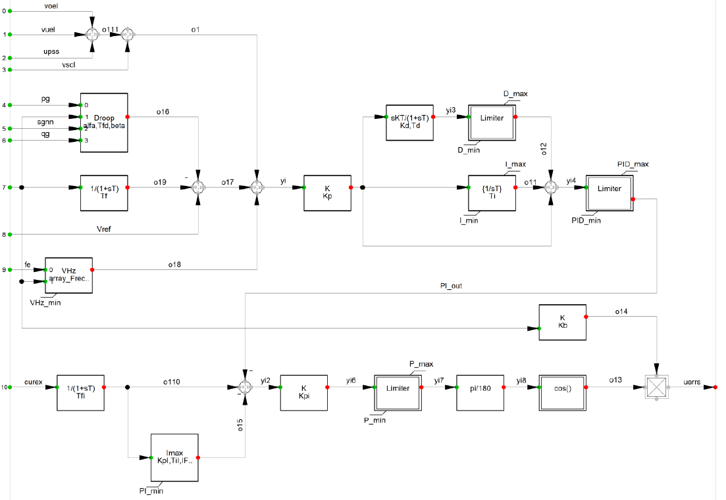

D

C

B

Figura 2. . Diagrama de bloques del AVR - A

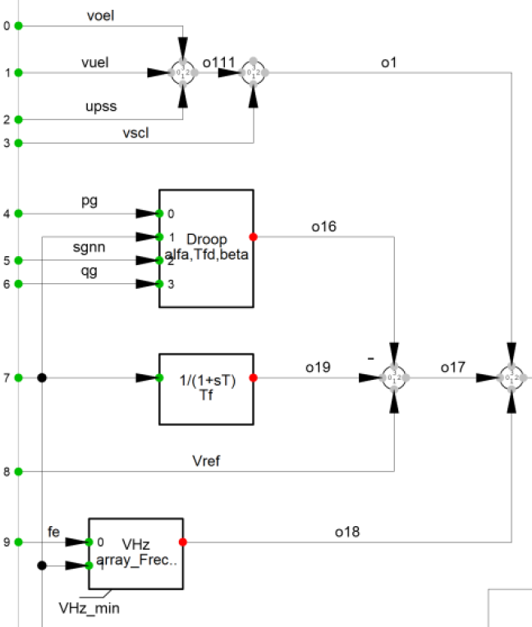

Figura 3. . Diagrama de bloques del AVR - B

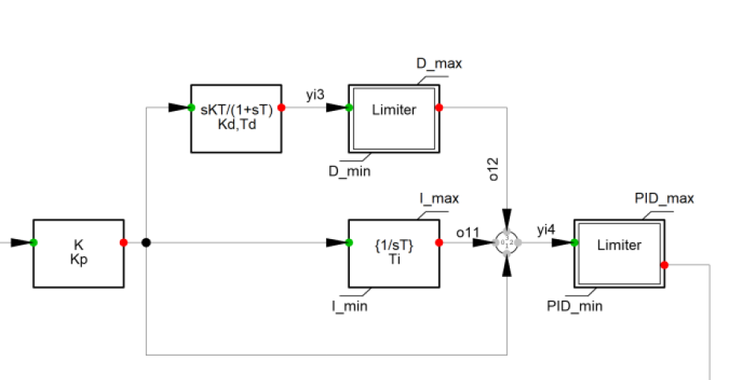

Figura 4. . Diagrama de bloques del AVR - C

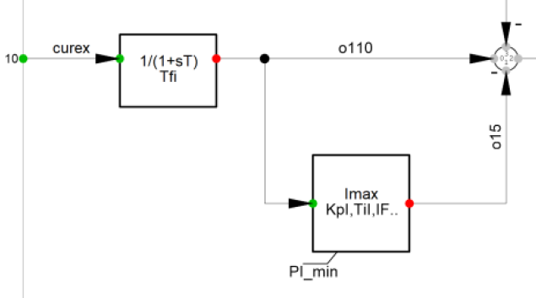

Figura 5. Diagrama de bloques del AVR - D

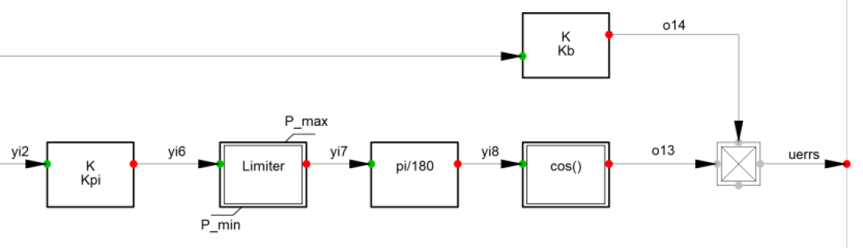

Figura 6. Subsistema AVR - Droop

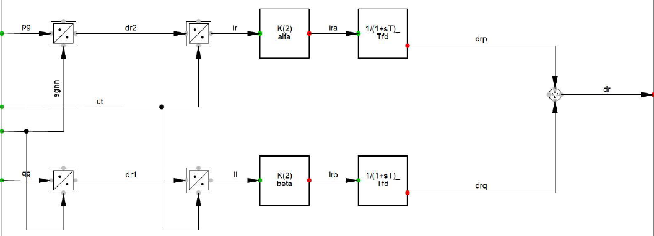

Figura 7. Esquema de inicialización slot “NomValue”

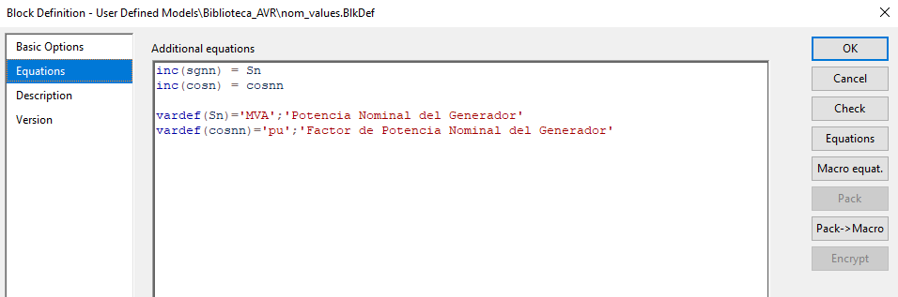

Figura 8. Diagrama de bloques del limitador V/Hz

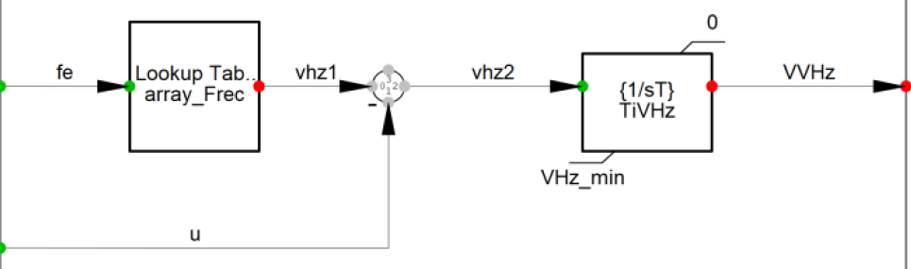

Figura 9. Diagrama de bloques del OEL instantáneo

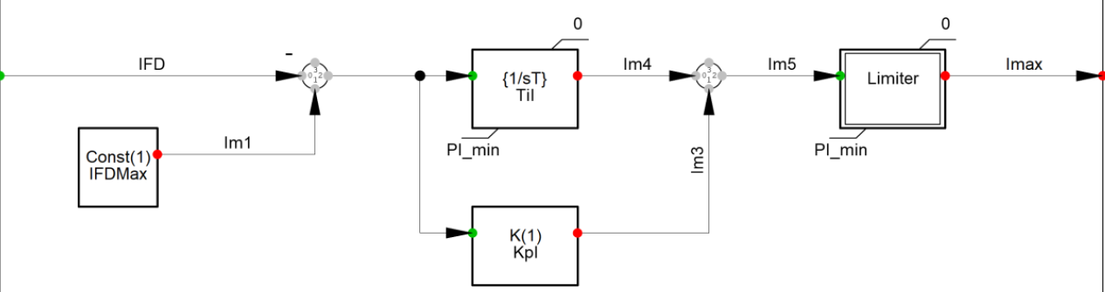

Figura 10. Diagrama de bloques del OEL temporizado

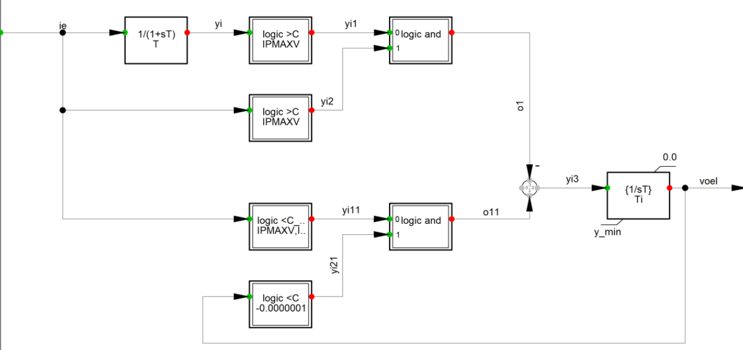

Figura 11. Diagrama de bloques del UEL

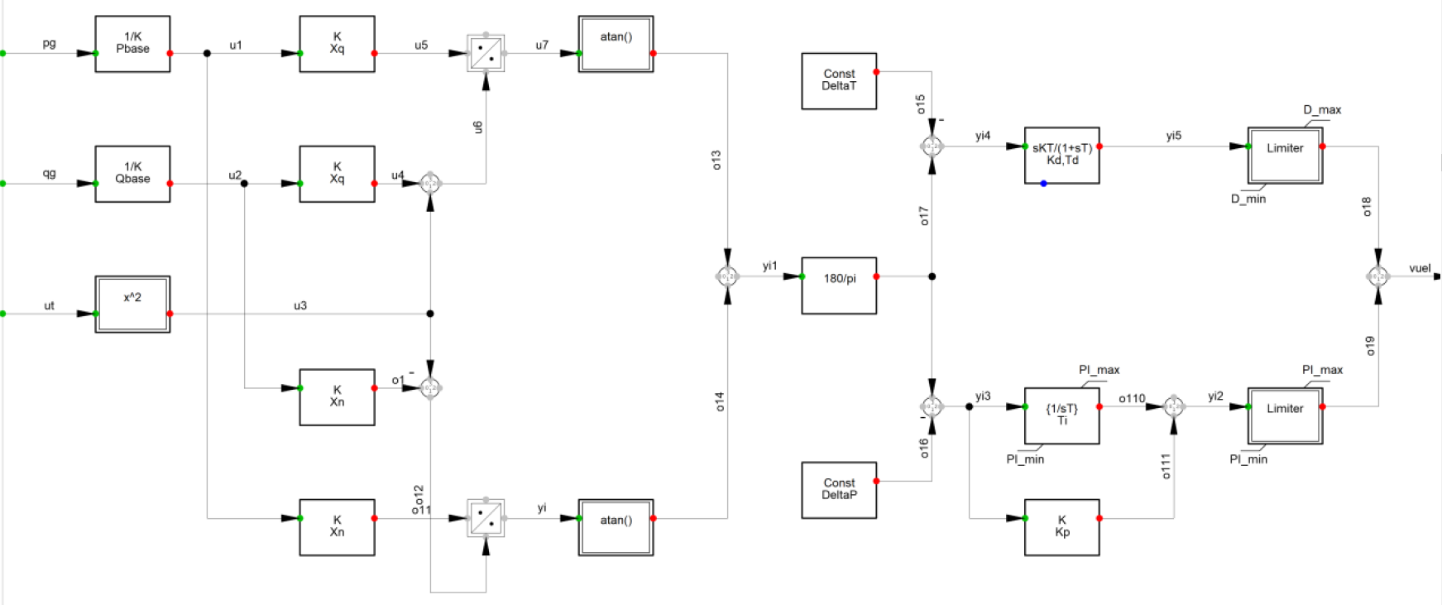

E

D

C

B

A

Figura 12. Diagrama de bloques del UEL - A

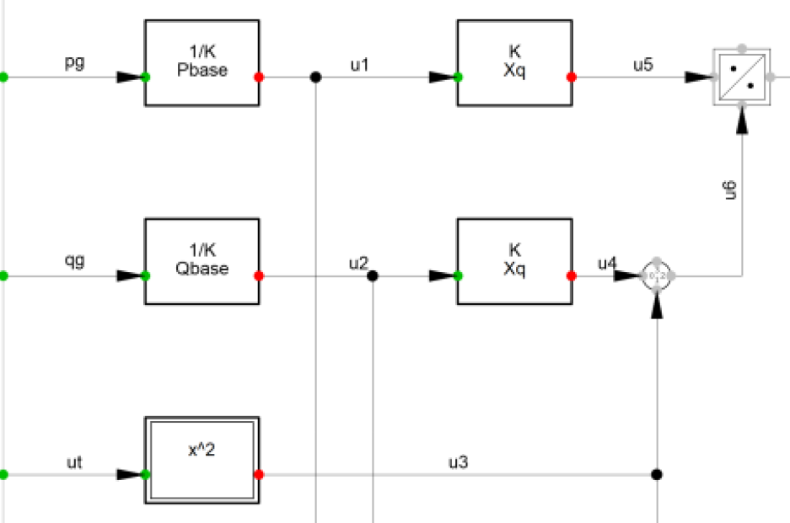

Figura 13. Diagrama de bloques del UEL - B

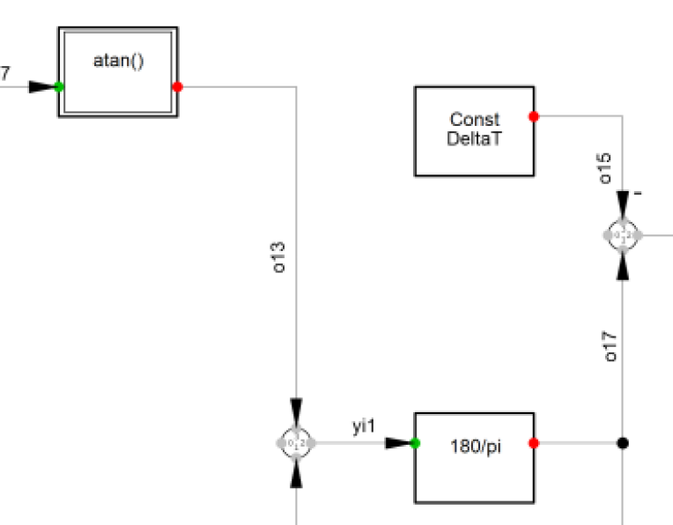

Figura 14. Diagrama de bloques del UEL - C

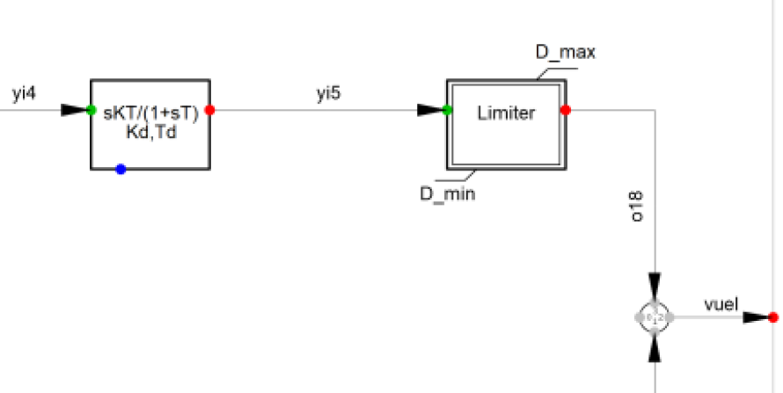

Figura 15. Diagrama de bloques del UEL - D

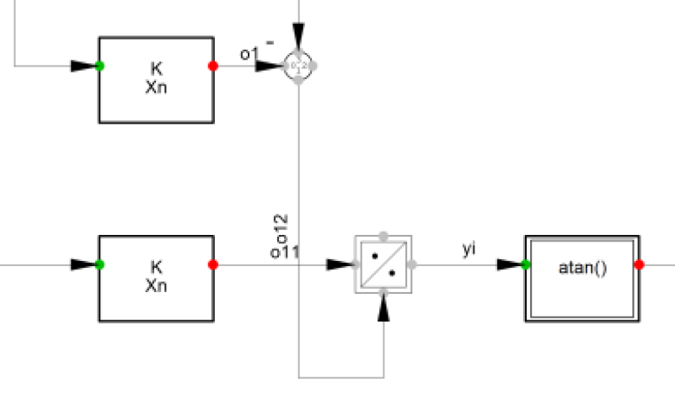

Figura 16. Diagrama de bloques del UEL - E

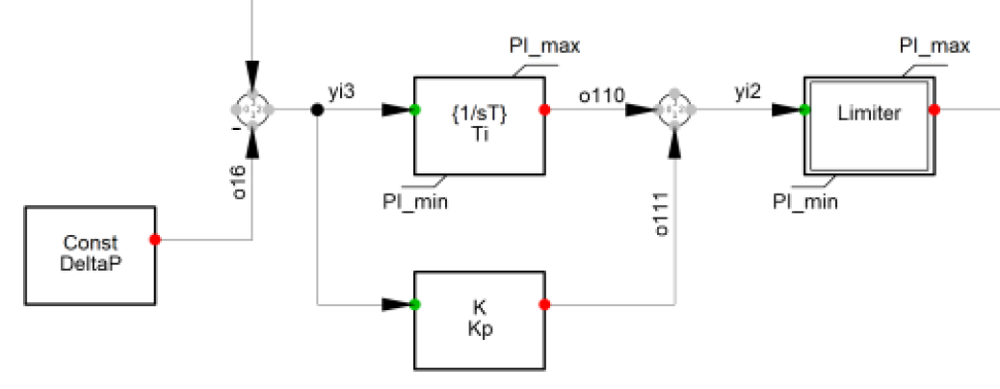

Figura 17. Diagrama de bloques del SCL

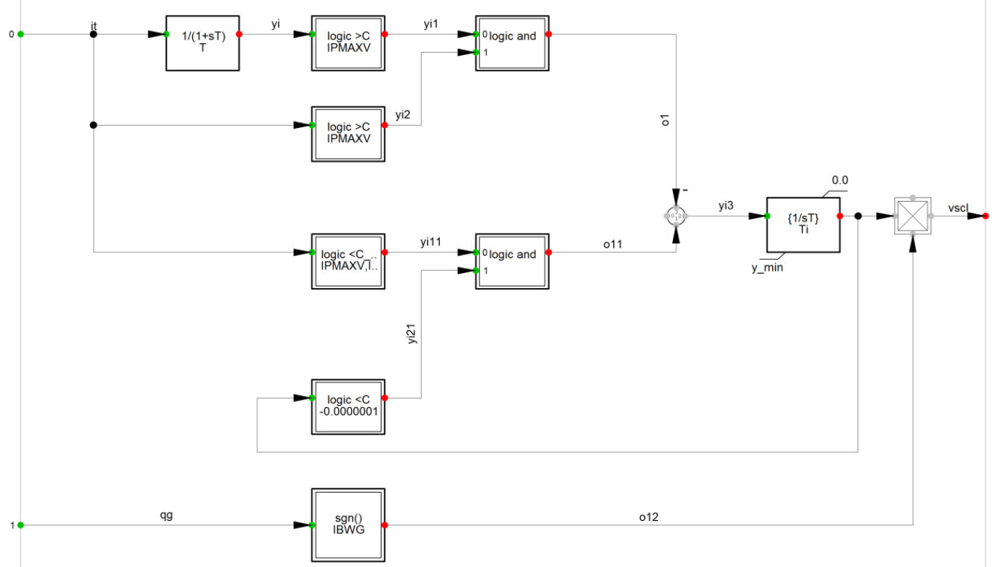

Figura 18. Diagrama de bloques del PSS

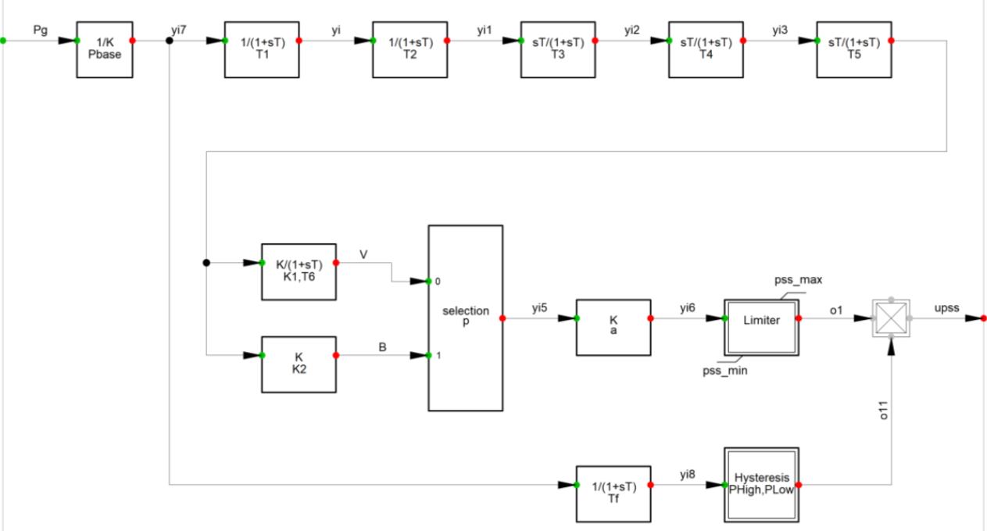

Figura 19. Modelo de conducciones hidráulicas

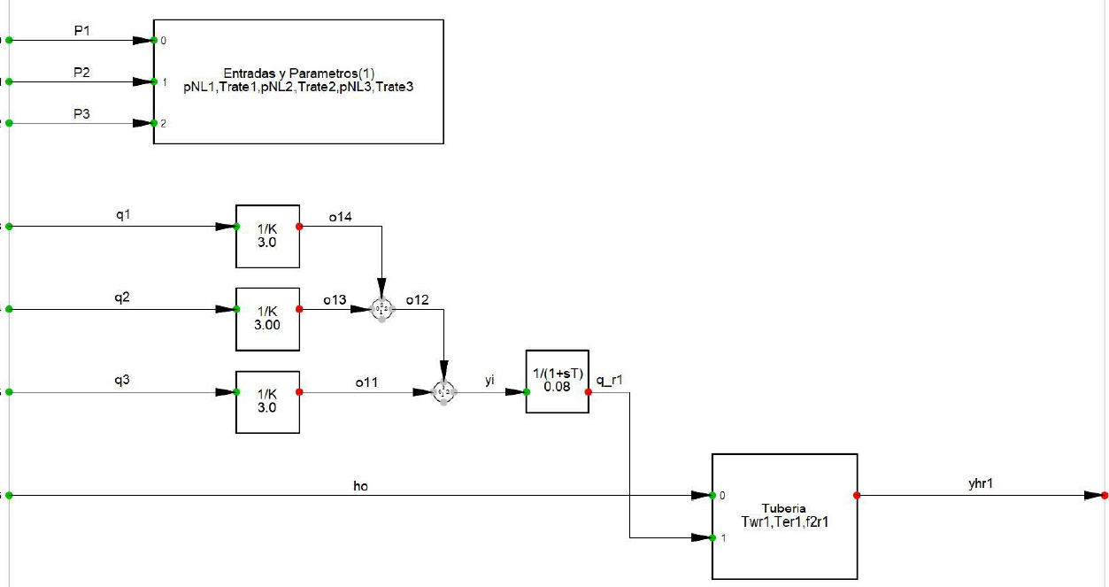

Figura 20. Diagrama en bloques del modelo turbina-penstock

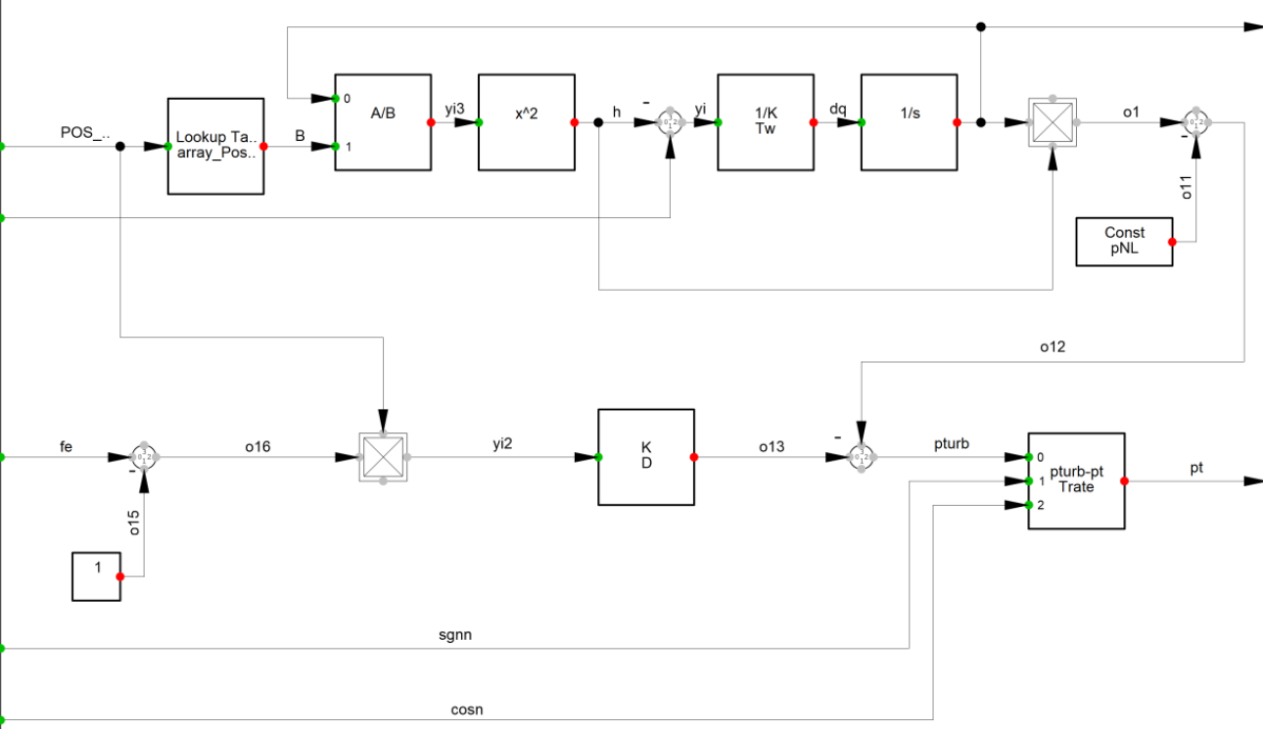

Figura 21. Diagrama de bloques del regulador de velocidad

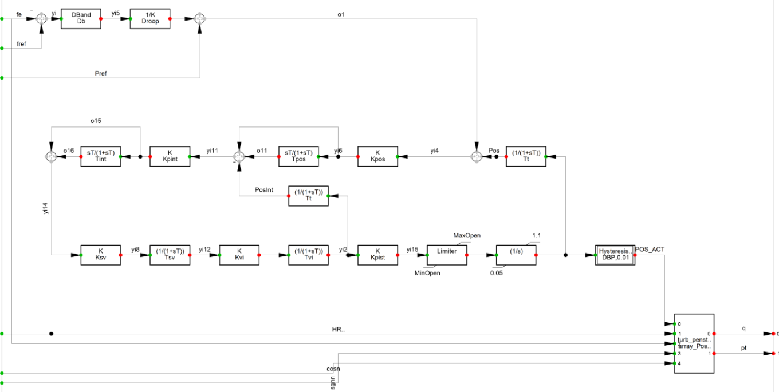

E

D

C

B

A

Figura 22. Diagrama de bloques del regulador de velocidad - A

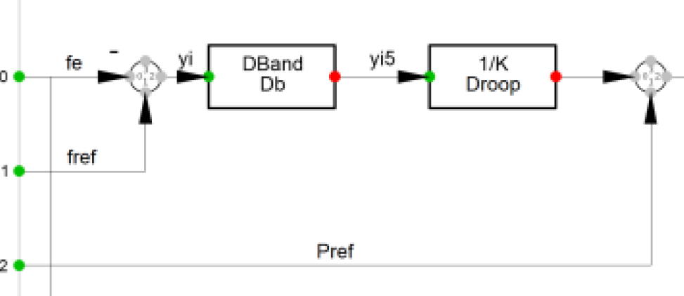

Figura 23. Diagrama de bloques del regulador de velocidad - B

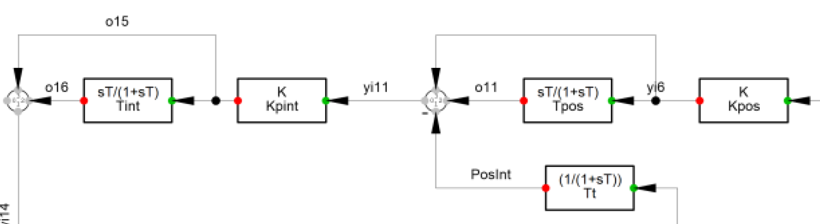

Figura 24. Diagrama de bloques del regulador de velocidad - C

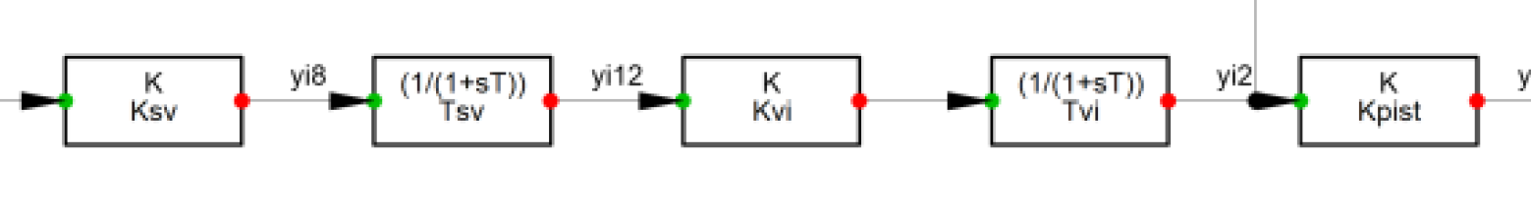

Figura 25. Diagrama de bloques del regulador de velocidad - D

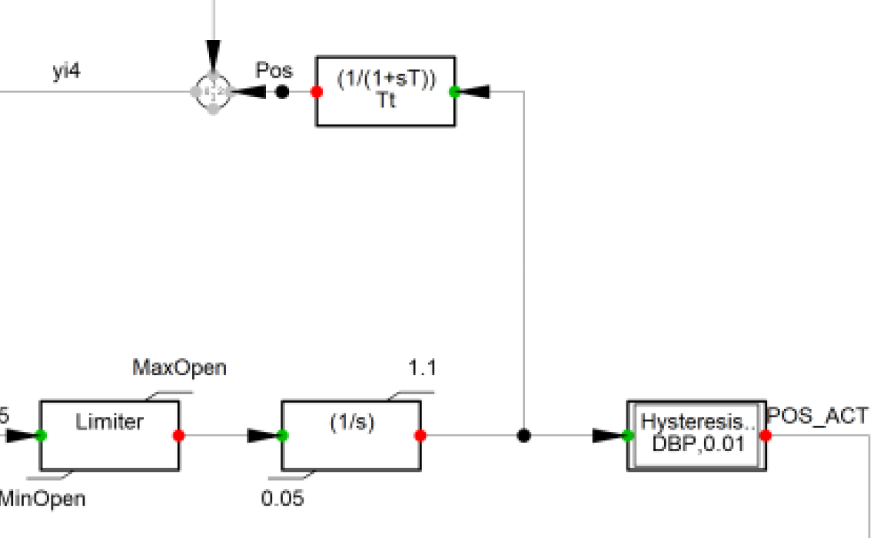

Figura 26. Diagrama de bloques del regulador de velocidad - E

